Yelp: <https://www.yelp.com/biz/the-show-corvallis-5>

About: The owner took over this restaurant since 2017. But they have worked in the Chinese restaurant for over 20 years. Customers don’t need to worry about the dishes are not authentic. They are quite expert.

Grandma’s Pork Pot Stickers - $ 6.95

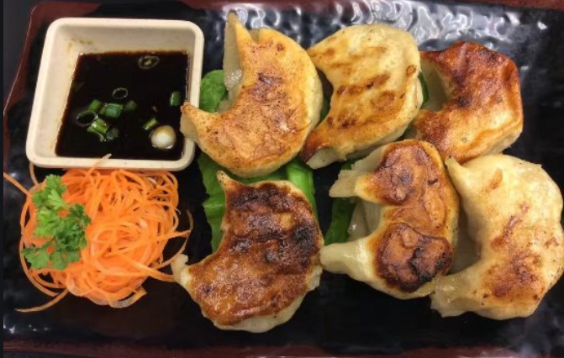

Egg Roll - $ 3.95

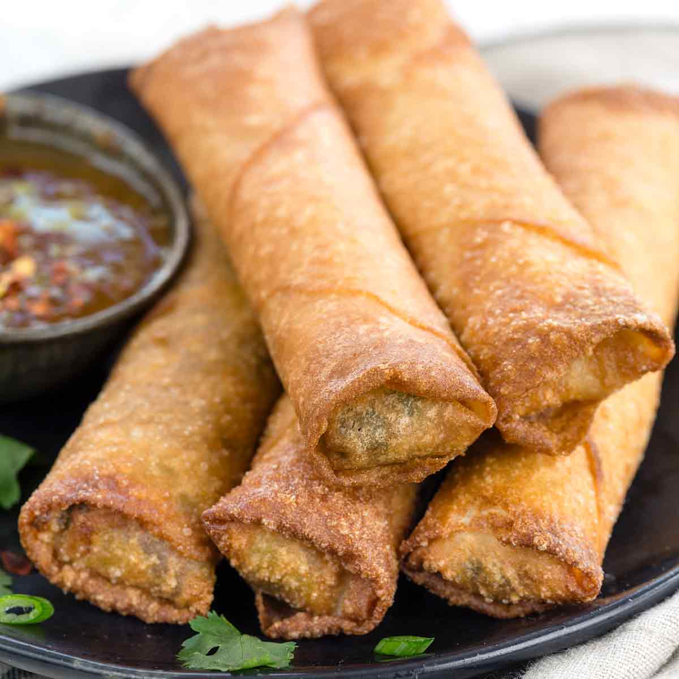

Hot & Sour Soup - $ 8.95

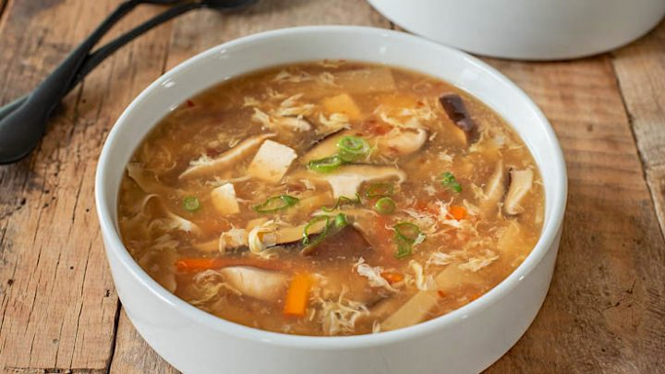

Garlic Spiced Pork Ribs - $ 14.95

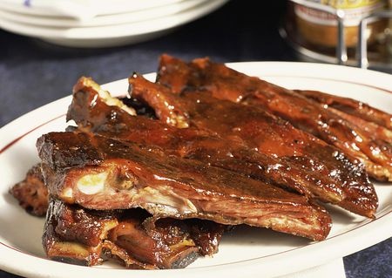

Curry Beef - $ 13.95

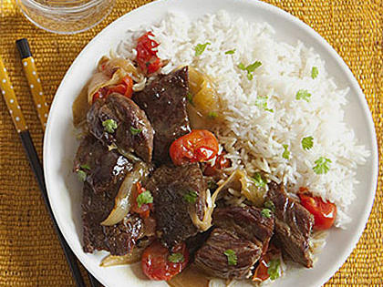

Mapo Tofu - $ 10.95

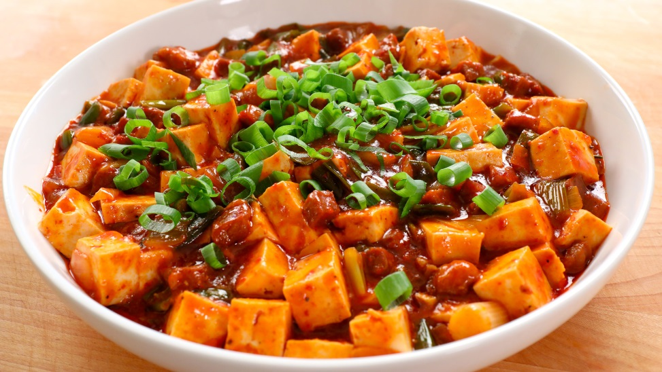

Stir-Fried Eggs/w Tomatoes - $ 10.95

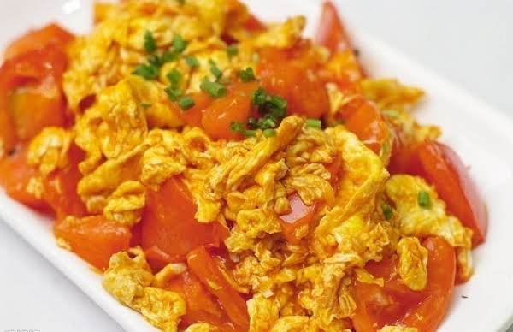

Dried-Cook Green Beans - $ 10.95

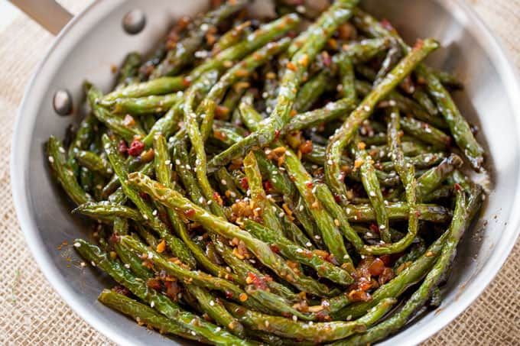

House Fried Rice - $ 12.95

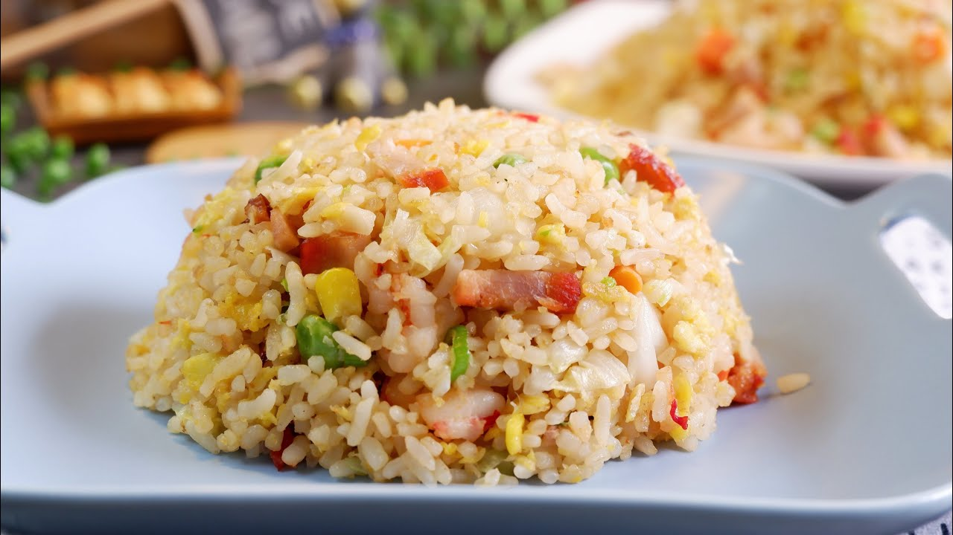

Seafood Noodles Soup - $ 13.95

